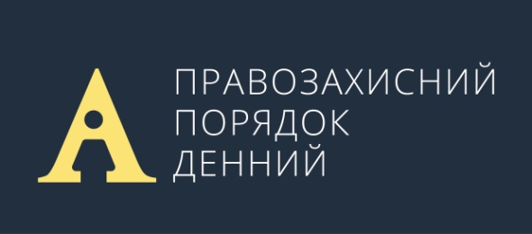

HUMAN RIGHTS AGENDA

Statement of the Human Rights Agenda platform demanding the President of Ukraine and the Verkhovna Rada of Ukraine stop crack-down on non-governmental organizations

In early July 2017, the presidential draft laws No. 6674 and No. 6675 were registered in the Parliament of Ukraine. The draft laws were elaborated allegedly to replace the scandalous amendments to the anti-corruption legislation obliging the anti-corruption activists to annually file personal asset and property electronic declarations (Law of Ukraine No. 1975-VIII of 23 March 2017). The presidential draft laws actually propose to abolish the e-declarations for public anti-corruption activists but to require instead the non-governmental organizations and individual entrepreneurs as well as enterprises, institutions and organizations providing them with services, to file additional reports to tax authorities.

The draft laws No. 6674 and No. 6675 burden all non-governmental organizations and individual entrepreneurs, enterprises, institutions and organizations that provide them with services with an unjustified obligation to file additional tax reports.

It is revealing that the number of tax reports required from the non-governmental organizations, which these draft laws provide for, significantly exceeds the number of reports required from the business. Moreover, even the recipients of budget funds are not required to file such a number of tax reports.

We believe that these legislative initiatives appeared not by chance, though against the background of statements about the need to reduce excessive state regulation. The punishment in form of the abolition of a non-profit status of non-governmental organization is pronouncedly punitive in nature and is nothing more than the introduction of a tool for selective pressure on the non-governmental organizations indisposed towards the authorities.

We regard the initiative of the President of Ukraine as the disproportionate interference in the activities of the non-governmental organizations. Such steps liken Ukraine to the repressive regimes of the Russian Federation, Kazakhstan, Azerbaijan, Turkmenistan and others similar. Despite the ostentatious care for transparency and accountability, the regulations introduced in the abovementioned countries led to almost absolute annihilation of the non-governmental organizations which are independent from authorities and total crack-down on civil society.

No international treaties require similar state control over the activities of non-governmental organizations as the international standards endow the non-governmental organizations with the right to be free from state interference in their activities.

The Guidelines on Freedom of Association drafted by the Council of Europe and the OSCE stipulate that "the state shall not require but shall encourage and facilitate associations to be accountable and transparent." Special reporting is permissible, however, if it is required in exchange for certain benefits, provided it is “within the discretion of the association to decide whether to comply with such reporting requirements or forgo them and forsake any related special benefits, where applicable.”

In consideration of the foregoing, we demand that the Parliament of Ukraine immediately reject the draft laws No. 6674 and No. 6675 of 10 July 2017 and the President of Ukraine fulfill his promise to cancel the amendments to the anti-corruption legislation dated March 2017.

For reference: the Human Rights Agenda platform is the informal coalition of human rights organizations working in the field of monitoring, analyzing and elaborating the legislation in accordance with the basic principles of human rights and fundamental freedoms. The platform participants are the Ukrainian Helsinki Human Rights Union, the Kharkiv Human Rights Protection Group, the Center for Civil Liberties, the Amnesty International Ukraine, the Human Rights Information Center, the Center for Law Enforcement Studies, the Without Borders Project of the NGO “Social Action Center” and the Euromaidan SOS. The Center for Civil Liberties coordinates the platform activities. Contacts: human.rights.agenda.ua@gmail.com

Center for Civil Liberties
Kharkiv Human Rights Protection Group
Kharkiv Institute for Social Researches
Eastern-Ukrainian Center for Civic Initiatives
Charitable Foundation “Vostok SOS”
Luhansk Regional Human Rights Center “Alternative”
Association of Ukrainian Human Rights Monitors on Law Enforcement
NGO “KyivPride”
Ukrainian Helsinki Human Rights Union
Open Dialog Foundation
Human Rights Information Center
Crimean Human Rights Group

The statement is open for signature. Please contact us at human.rights.agenda.ua@gmail.com

